

|  |  |  |  |
| --- | --- | --- | --- |
| **Subject** | Digital Technologies | **Task Name** | CSS Project |
| **Semester** | 1 | **Task Number** | 2 |
| **Teacher** | Mr Henley | **Type** | Digital Project |
| **Due date** | 13 May 2021 | **Authorship** | Individual |
| **Context** | | | |
| Oceanic Airlines is a new airline servicing the Australia, New Zealand and the Pacific Islands. Oceanic Airlines requires a website to be built to promote their brand. A technical proposal outlining the requirements for the website has been supplied. | | | |
| **Task Description** | | | |
| Develop the CSS for a website according to the requirements outlined in the provided technical proposal for this client. Document the problem solving process and demonstrate the functionality of the website by building a working website | | | |
| **Conditions/Submissions** | | | |
| * You have three weeks to complete this task * The task is to be completed individually * Class time provided to work on your task * Draft is due one week before final submission | | | |
| **Think about** | | | |
| How will you demonstrate each of the criteria in the standards elaborations? | | | |

**Technical Proposal**

**Introduction**

Your client has contracted you to design a website that has a consistent look and feel. Currently they have a HTML only site that lacks visual appeal and as a result is difficult to navigate. The client wants you to add CSS to make the site visually more appealing and more functional as a result. The home page has been sent to you so you can work on the design.

Your website must contain the following elements:

* A colour scheme that matches the Oceanic Airlines logo
* A navigation bar styled with CSS
* A complete home page containing links to content pages within the website. The other pages need a statement that the site is under construction
* Consistent styling (eg. for hearings, paragraphs, background colours, image size etc.)

The client has sent an artist’s impression for what they home page may look like. You can see this below:

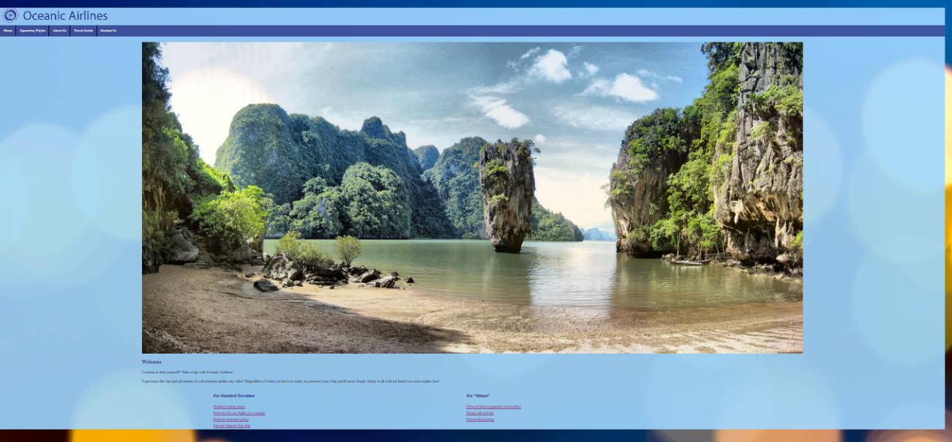

**Client**

Oceanic Airlines is a charter airline servicing the Pacific. They want their website that have a consistent colour scheme and a layout that makes navigation easier for its customers.

**Target Audience**

Oceanic Airlines target audience is wealthy individuals who first class service to remote pacific islands not serviced by the major airlines.

**Explain the benefits of separating HTML from CSS**

(100 words)

**Evaluation**

(100 words)

(Is there any risk involved with your solution? How sustainable is it? Could the website be improved so it provided more functionality for users?)

## Years 9 and 10 Digital Technologies standard elaborations

|  | | A | B | C | D | E |
| --- | --- | --- | --- | --- | --- | --- |
|  | | The folio of a student’s work has the following characteristics: | | | | |
| Knowledge and understanding | Representation of data | comprehensive explanation of:   * why content data are separated from presentation | detailed explanation of:   * why content data are separated from presentation | explanation of:   * why content data are separated from presentation | description of:   * why content data are separated from presentation | statements about:   * why content data are separated from presentation |
| Processes and production skills | Generating and designing;  producing and implementing | systematic testing and prediction of results and proficient implementation of digital solutions | reliable testing and prediction of results and effective implementation of digital solutions | testing and prediction of results and implementation of digital solutions | partial testing and prediction of results and partial implementation of digital solutions | fragmented testing and prediction of results or fragmented implementation of digital solutions |
| Evaluating | discerning evaluation of information systems and their solutions in terms of risk, sustainability and potential for innovation and enterprise | informed evaluation of information systems and their solutions in terms of risk, sustainability and potential for innovation and enterprise | evaluation of information systems and their solutions in terms of risk, sustainability and potential for innovation and enterprise | explanation of information systems and their solutions | description of information systems and their solutions |

|  |  |
| --- | --- |
| Key | shading emphasises the qualities that discriminate between the A–E descriptors |